# CHAPTER 8

**Part A**

**Q1. Is it possible to live in relationship without understanding relationship? How is a family the basic ground for understanding relationships? Explain.**  
Every human being is born in a family and is part of a family, in which there are parents, grandparents, children, youth, uncles and aunts, cousins, so many relatives and friends. It is the family where we are nurtured and developed from childhood, cared for in sickness and in old age. It is where we start learning to interact with other human beings, to share and to care. It is the place where we start becoming aware of relationship. The moment we hear the word mother, there is a whole lot of feeling. Similarly, every relationship name has an associated feeling which becomes more and more enriched as we interact. Our basic grooming for living in relationship starts in the family. The first few years, what we call the formative years, are spent in the family. It is where we pick up a very significant part of our sanskar in living with our family elders and siblings, neighbours and friends. It also provides us the platform to verify our understanding. The family is the basic unit or building block of human organisation. It is a practice ground for living in relationship and harmony.

**Q2. ‘Relationship is – between one Self (I1) and another Self (I2)’. Examine this statement.**  
When we talk about relationship, we can make two important observations.   
The first is that the relationship is already there, we are in fact embedded in relationship. We are already related to each other – whether we recognize it or not. We do not have to construct or create relationship. All we need to do is to understand relationship. We are part of a family, with the parents, grandparents, brothers and sisters. We have neighbours, relatives and friends. We are connected to the people who are producing, processing, packaging, marketing, delivering, repairing all the things we use. We are dependent on the people who provide services to us. There are a lot of people who depend on us – for the goods and services that we produce or provide.  
The second observation is that relationship is between one Self and the other Self. Of course, the relationship exists between one human being and the other human being. However, understanding human being, we can easily see that it is the Self which is recognizing the relationship, and not the Body. It is the Self which has feelings in relationship, and not the Body. Also, these feelings are recognized by the other Self and not the Body. In that sense, the relationship is between one Self and the other Self. It is the Self that is able to see or understand relationship, accept relationship and fulfil relationship. The Body may be used as an instrument in the process of fulfilling the relationship by both human beings.

**Q3. Feelings in the Self are fundamental to live with fulfilment in relationship. Evaluate this statement.**  
The important issue in human relationship is that of the feelings. We can see that feelings are in the Self, not in the Body. It is the Self which has the feelings and which recognises the feelings. To understand relationship, one has to understand the Self and the feelings in the Self. Feelings like respect and affection are more important rather than merely the exchange of physical facility. For example, you are happy with your mother’s cooking even if it is very simple, because of the feelings in that relationship. You may complain about very similar hostel mess food, if you haven’t realised the feelings in the relationship with the mess staff.  
The major crisis we are facing in relationship today is because of the failure to understand the Self. We are trying to assume relationship on the basis of body, trying to fulfil relationship on the basis of body and it does not work. If we don't understand the Self, we don't understand the feelings and therefore, we are not able to ensure the fulfilment of the feelings in relationship. We end up trying to ensure the fulfilment of the relationship through physical facility.

**Q4. What are the feelings (values) in human relationship? Are they naturally acceptable to you? Do you think these feelings are also naturally acceptable to others?**  
There are nine feelings in relationship. These are the feelings which we can understand which we can ensure within ourselves which we can share with others and thus ensure mutual fulfilment in relationship. These are the feelings which are naturally acceptable to us in the relationship with the other human being.  
1. Trust (foundation value)   
2. Respect   
3. Affection   
4. Care   
5. Guidance   
6. Reverence  
7. Glory  
8. Gratitude  
9. Love (complete value)  
These feelings are naturally acceptable to you, therefore, having these feelings in yourself leads to your happiness. When you have a feeling of respect within you, you are comfortable within, you are in harmony within – because this feeling of respect is naturally acceptable to you. When you are in harmony within, you are in a state of happiness. On the other hand, if you have a feeling of disrespect for the other, you are uncomfortable within because you are in contradiction within – the feeling of disrespect is not naturally acceptable to you. Just by having this feeling of disrespect, it leads to contradiction within yourself and therefore, leads to a state of unhappiness within.

**Q5. What is the outcome when we try to identify relationship based on the exchange of physical facility alone?**  
We, therefore, fail to understand relationship and consequently, we fail to fulfil relationship, despite all our good intentions. That is why, we have so much of complaint regarding relationship. We keep thinking and talking about the lack of fulfilment in relationship, but we hardly know what to do about it. Most of the time, finding lack of fulfilment of relationship, we try to fulfil it through physical facility, but it does not work. We have observed that much of our unhappiness has to do with the lack of fulfilment in relationship, while we may be spending major part of our time and effort for physical facility.

**Part B**

**Q1. What is the proposal for the definition of trust? Illustrate the feeling of trust with one example, preferably from your own experience.**  
**Trust is to be assured that the other intends to make me happy and prosperous.**Since our basic aspiration is happiness, prosperity and its continuity, so if we are clear that the other person wants to make us happy and prosperous, we feel assured of him – that’s what is meant by having a feeling of trust. On the other hand, if we have even a small doubt that the other person wants to make us unhappy or deprived, we will not feel assured of him. We will have doubt and apprehension or fear. We will have the feeling of mistrust for him.  
Give example.

**Q2. Distinguish between intention and competence. What is the outcome when we confuse between the two and we doubt the intention of the other? What is the outcome when we are able to see them separately and we trust the intention of the other?**  
As far as your performance is concerned, your action is concerned, even if you make the same mistake hundred times, you never doubt your intention. You feel that you make mistakes by accident. You have a feeling that you are well meaning. You reinforce that you are good. And, mostly you do not make effort to improve upon your competence.  
On the other hand, for the other, we keep concluding that he makes mistakes intentionally. We have this doubt on his intention. We assume his lack of competence to be the lack of intention. When we doubt the intention, we have a feeling of mistrust or even opposition. And if we have this feeling of opposition, we tend to get irritated; we tend to get angry and so on. We conclude that his intentions are wrong. By doing this, we reinforce the belief that the other is bad, he cannot improve and thus we do not bother to help him improve his competence.  
On the basis of lack of competence, we conclude about the lack of intention of the other. When we doubt their intention, instead of accepting the other as a relative, we have a feeling of opposition. This feeling of opposition will come out as irritation or anger and so on.  
If you have trust on intention of the other and if you find that the other is lacking competence, you will try to improve upon his competence. On the other hand, if you have doubt on intention of the other, you will get irritated or angry or carry a feeling of opposition.  
This is important that I am trying to improve upon his competence, trying to help to improve upon his competence with a feeling of relationship. When I am doing this with a feeling of trust, I can see that he may have difficulty in understanding and also, I may have difficulty in explaining. When I am trying to explain and he is not able to understand, I do not doubt his intention to understand. I can see that he is finding it difficult to understand because of lack of his competence and it might also happen that I am not able to explain properly because of lack of my own competence. If I can see that, I will try to improve upon my competence and I will try to improve upon the competence of the other. And if I am unable to do that, at least I will not have a feeling of opposition, irritation or anger.

**Q3. ‘If I trust the intention of everyone, people would take undue advantage of me’. Is this statement true or false? Explain.**  
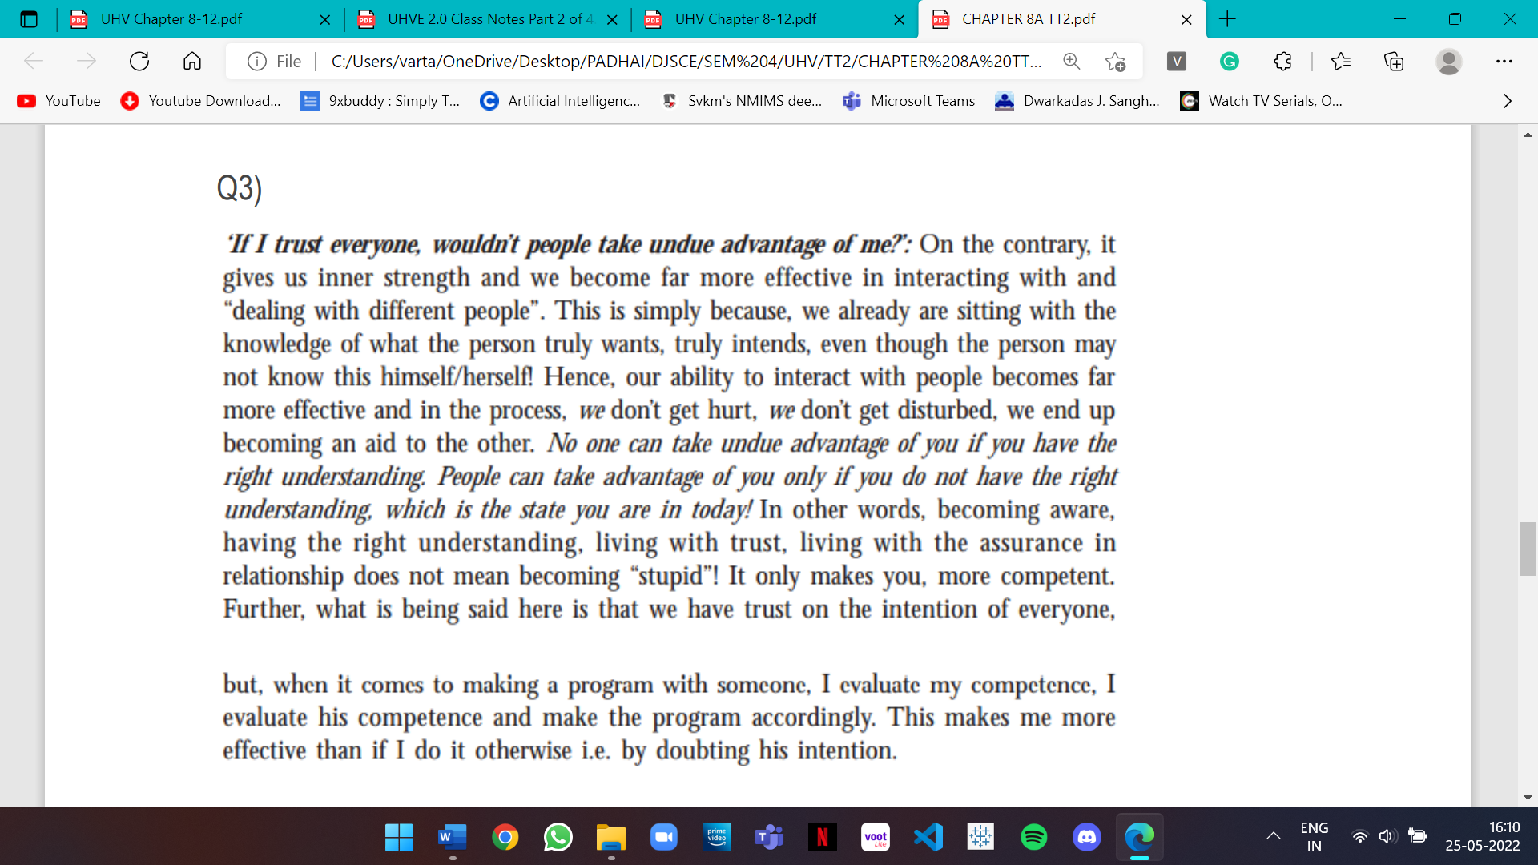

**Q4. How is trust the foundation value of relationship?**  
When we assume trust (rather than understand trust), we may assume the other has the intention and also has the competence. That means we do not evaluate the competence while making the programme. If we make the programme without evaluating our own competence and without evaluating the competence of the other, the programme is likely to fail; and we may conclude not to trust anybody.  
When we understand trust, it makes all the difference – we accept the other as he is. He is just like me. He has the intention to be happy and make me happy. His competence may or may not be matching his intention.   
This trust on intention gives a direction for our effort. While making a programme, we base it on our evaluation of mutual competence. The programme may succeed or it may fail, but we are not perturbed. We make effort to assure the other. We are able to re-evaluate our mutual competence for future programs. We are committed to help the other to improve his competence, without becoming irritated, angry and all that. We are, at the same time, making effort to learn, to improve our own competence.  
Trust on intention is the starting point for mutual development. That is where the relationship begins. It is in that sense we are saying that trust on intention is the foundation of relationship.

**Q5. Distinguish between reaction and response with the clarity of feeling of trust. Give one example of each for a particular case of relationship.**  
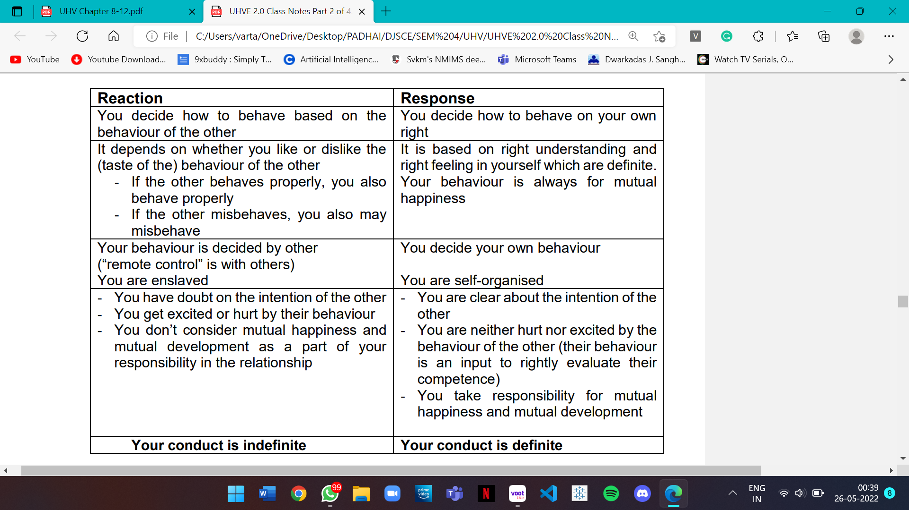

**Q6. Distinguish between intention and desire. Take at least one example.**  
**Trust is to have the clarity that the other intends to make me happy.**Our intention is the same as our natural acceptance. On the other hand, competence is what we are – the collection of all desires, thoughts and expectations, i.e. all of our imaginations. Since desires may be coming from preconditioning, sensation as well as natural acceptance; desire is not necessarily the same as intention. Only some part of the desires that are coming from natural acceptance are our intention, the others may or may not be our intention.  
For instance:   
• Our natural acceptance (intention) is to be happy and make others happy, but we may have a desire for taking revenge  
• We keep getting hurt by the behaviour of others and we keep hurting others with our behaviour. We don’t have a natural acceptance for it, but it is a part of our desire.  
Competence includes all the desires, thoughts and expectations (from all three sources). The intention (natural acceptance), on the other hand, is always same – to be happy and make the other happy.

**Part C**

**Q1. Respect is right evaluation (on the basis of the Self). List some of the prevailing notions regarding the feeling of respect. Examine these notions as well as the proposal for the feeling of respect.**  
Respect means right evaluation. It is as simple as that. When we are rightly evaluated, we feel respected. When we are not rightly evaluated, we feel disrespected.  
The human being is co-existence of Self and Body, we can think in terms of evaluating the human being on the basis of Self, and ensuring the right evaluation. If we go about doing this, let’s see these three things:  
**Our purpose is the same** – I have a natural acceptance to live with continuous happiness and prosperity. That is my purpose. The other also has a natural acceptance to live with continuous happiness and prosperity. That is the purpose of the other. So, on the basis of our natural acceptance, we have the same purpose.  
**Our program is same** – My program to achieve continuous happiness and prosperity is to understand the harmony and live in harmony at all levels of my being (from human being to the entire existence). The program for achieving his purpose, the program of the other is also to understand the harmony and live in harmony at all levels of being. In that sense, our program to fulfil our purpose is also same.  
**Our potential is same** – I am endowed with natural acceptance and the activities of desire, thought and expectation are going on continuously in me. This is my basic potential (to understand, think and do). The other is also endowed with natural acceptance; and the activities of desire, thought and expectation are going on continuously in the other. So, our potential is also same.

**Q2. The minimum content of respect is to be able to see the other person as being similar to you. On what basis is the other similar? What is the complete content of respect?**  
The human being is co-existence of Self and Body, we can think in terms of evaluating the human being on the basis of Self, and ensuring the right evaluation. If we go about doing this, let’s see these three things:  
**Our purpose is the same** – I have a natural acceptance to live with continuous happiness and prosperity. That is my purpose. The other also has a natural acceptance to live with continuous happiness and prosperity. That is the purpose of the other. So, on the basis of our natural acceptance, we have the same purpose.  
**Our program is same** – My program to achieve continuous happiness and prosperity is to understand the harmony and live in harmony at all levels of my being (from human being to the entire existence). The program for achieving his purpose, the program of the other is also to understand the harmony and live in harmony at all levels of being. In that sense, our program to fulfil our purpose is also same.  
**Our potential is same** – I am endowed with natural acceptance and the activities of desire, thought and expectation are going on continuously in me. This is my basic potential (to understand, think and do). The other is also endowed with natural acceptance; and the activities of desire, thought and expectation are going on continuously in the other. So, our potential is also same.  
When we are able to see the human being is the co-existence of Self and Body, we can see that the other (Self) is similar to me because our purpose is same, programme is same and potential is same. This is the minimum content of respect for a human being. Having understood that our purpose is same and our potential is also same, we use the difference in competence to help each other in further developing our competence. So, we are complementary to each other. So, being able to see that ‘the other is similar to be and we are complementary’ is the complete content of respect.  
**The complete content of respect is:  
• The other is similar to me in terms of purpose, programme and potential and   
• We are complementary to each other in terms of competence**

**Q3. Give one example each of over evaluation, under evaluation and otherwise evaluation. Why are these evaluations leading to disrespect? What problems do we face because of these wrong evaluations?**  
**Over evaluation – evaluating for more than what it is  
Under evaluation – evaluating for less than what it is   
Otherwise evaluation – evaluating for other than what it is**   
For example, when you are happy with a child, you start saying that he is great, he can do anything. It is an over evaluation. If you are angry with him for some reason, you say, he's good for nothing, he cannot do anything. It is an under evaluation. If you are really very angry with him, you say he is a donkey. You are not even willing to consider him as a human being. He is a human being and you are evaluating him for donkey, for an animal. This is otherwise evaluation.   
If we look at our day-to-day interaction, day-to-day behaviour, we generally tend to do one of these three – over evaluation, under evaluation or otherwise evaluation. If any of these three is done, the other person feels uncomfortable, disrespected.  
As long as I don’t have my own right evaluation (based on right understanding of human being), I can’t do right evaluation of the other. Over and above that, this over-evaluation tends to ego, and under-evaluation or otherwise evaluation to depression; whether I am the one doing my own over/under/otherwise evaluation or someone else is doing it. When I am in ego, my behaviour with the other is likely to be reactive and not mutually fulfilling. Similarly, when I am in depression, I am unhappy and tend to make others also unhappy.

**Q4. How do we differentiate in relationships on the basis of body, physical facility or beliefs? What problems do we face because of such differentiation?**  
One criterion for the differentiation is on the basis of body. One set of our basic criteria for giving respect is related to body – on the basis of age, gender, race and physical strength. Since we are not able to see this similarity generally, we are not able to see that children also need respect, just as older people do. Like this, we are differentiating on the basis of age, we are differentiating on the basis of gender. Many societies give higher priority to the male as compared to females or vice-versa; or giving priority to white as compared to brown and black. Similarly, we have been giving respect to those having more physical strength.  
The second set of differentiation is made on the basis of physical facility – on the basis of wealth and on the basis of post. The one who has more wealth is given respect over the one who is not having as much of wealth. Similarly, the one with the higher post is given respect over the one who does not have higher post.  
The third set of bases of differentiation is what we can call beliefs. There are different isms (thought systems like socialism, capitalism, etc.), different sects, and different set of information available. Depending upon which particular set of beliefs you have, you are given respect or not given respect.  
It will give rise to disrespect and that is the problem today. If you see around, all these bases of giving respect are generally discriminating which is leading to disrespect and therefore a lot of dissatisfaction, lot of opposition, lot of movements and revolts. All this is the basis of differentiation and it is causing disrespect in the name of respect.

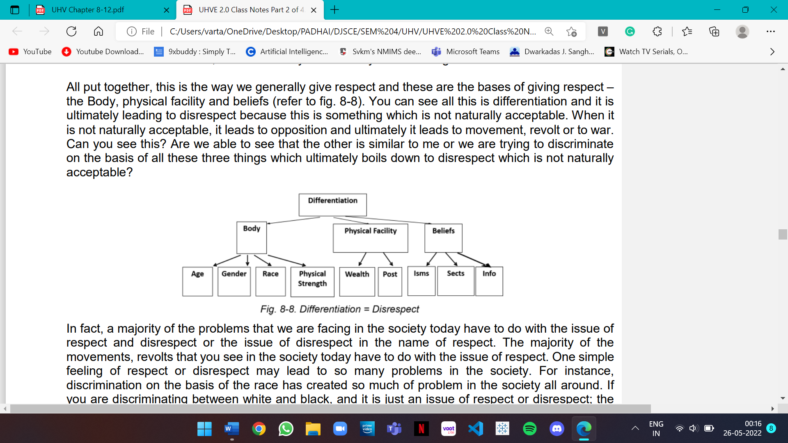

**Q6. How does the feeling of respect help us in defining our complementary with other human beings? What is the expression of the feeling of respect?**  
Having understood that our purpose is same and our potential is also same, we use the difference in competence to help each other in further developing our competence. So, we are complementary to each other. So, being able to see that ‘the other is similar to be and we are complementary’ is the complete content of respect.  
We define our complementarity by developing a joint program for mutual development and fulfil that complementarity. If I have not understood something and the other person has understood it, I can take help of the other to understand it. Similarly, I can be of help to the other by helping him to understand something that I have understood, which the other has not yet understood. In this way, the difference in competence does not lead to discrimination, but rather it leads to mutual fulfilment.   
**Looking into the details of complementarity:   
• If the other has more understanding, is more responsible than me, I’m committed to understand from the other   
• If I have more understanding than the other, I’m more responsible than the other, I live with the responsibility with the other, unconditionally, unperturbed by the behaviour of the other. I am committed to facilitate the understanding in the other, once the other is assured in relationship and not before that**

**Part D**

**Q1. Define affection. How does affection lead to harmony in the family?**Affection is the feeling of acceptance for the other as one’s relative. Parents generally have a feeling of affection for their children. The parents are very naturally able to relate to their children, feel concerned for them. Similarly, children feel related to their parents. This feeling can also be seen between friends, siblings, between teacher and student, between husband and wife, or any other relationship. It is a naturally acceptable feeling, and hence desired in every relationship. The feeling of affection is essential for the fulfilment of any relationship. Particularly, for children, it is a necessity for their development. The child feels secure in the early stages of development when it enjoys the affection of its parents. The parents, though having a hectic schedule, take care of the child, and feel happy and fulfilled in the process. But one important thing to note is that the feeling of affection can be there in continuity only if it is based on the feelings of trust and respect. If the first two feelings are not present in the Self, then the feeling of affection cannot be not continuous. Lack of affection is seen in the form of opposition or jealousy. Such things too are observed in relationships. If the feeling of affection is missing or lacking, then we feel opposed to the other and tend to have a feeling of jealousy. This can be seen even in very young siblings. For example, if a brother is not able to accept his younger sister, then he would not have a feeling of affection for her and he may keep vying for the parents’ full attention. The very feeling of trust is missing, so respect is also violated. Like this, the boy is jealous of his sister and considers her to be his competitor.

**Q2. Explain the feelings of care and guidance.**

We can see that when we have a feeling of affection then the responsibility and commitment comes naturally. This starts reflecting in terms of the feeling of care and guidance. They are the natural outcomes of the feeling of affection. It can be seen in terms of:

1. The feeling of responsibility towards the Body of my relative, and

2. The feeling of responsibility towards the Self of my relative.

**Care is the feeling of responsibility and commitment for nurturing and protection of the Body of my relative.**

To care for the child, they nurture and protect the Body of the child. This can be seen in most parents. Mothers are willing to do it even if it may cause inconvenience to them. They are seen skipping their own food for feeding the child on time, or change their complete routine of the day for the sake of the child.

**Guidance is the feeling of responsibility and commitment for ensuring the right understanding and right feeling in the Self of my relative.**

In families, we do try to guide the children to the best of our ability. We can observe how parents’ guide the child to walk, to speak, to take care of the Body, to do household chores, etc. Similarly, as the child grows, the domain of guidance also widens. Sending the child for education, providing advices for betterment of the life, counselling for a successful life, etc. can be seen in most homes. Parents and other family members pass on what they know or assume to the children. If they have the understanding of harmony, and they are living in harmony, they are able to provide guidance to the children in the true sense. Through it, the children also understand harmony and live in harmony.

**Q3. What is excellence? Is working for competition the same as working for excellence? Explain with the help of examples.**

What we are proposing is that excellence is to be in a state of continuous happiness. This calls for understanding harmony and living in harmony – at all levels of our being. Once we achieve excellence, it continues. Excellence is something definite, something absolute.

In a state of continuous happiness, there is nothing more that you need to do for yourself. Therefore, you would naturally make effort for helping others to achieve excellence. On the other hand, in competition, we not only do not help rather we hinder the other to reach to our level.

If we are making effort for excellence or helping others to achieve excellence, it is a joyous effort for all concerned. When we are competing, say for that first position in class or to be someone special, it is an unhappy effort for all concerned, including you.

**Q4. Distinguish between respect, glory and reverence.**

Respect is there for all on the basis of right evaluation of the Self. When we do the right evaluation on the basis of Self, we find that the purpose of every human being is the same – to achieve excellence.

**Reverence is the feeling of acceptance for excellence.**

When it comes to reverence, of course the respect is there at the base. In addition to that we have this feeling of reverence for those who have achieved excellence. From them, we would like to take inspiration and make effort for our excellence. That is the difference between the respect and reverence.

**Glory is the feeling of acceptance for those who have made effort for excellence.**

When it comes to glory, of course respect is there at the base, but glory is for those who have made effort to achieve excellence. To whatever extent they might have achieved it, but they have made effort for it. For them, we have a feeling of glory. If they have achieved excellence, we have this feeling of glory as well as reverence.

When it comes to reverence, the feelings of glory and respect are included in it. When it comes to glory, the feeling of respect is included in it, but reverence is not necessarily included in glory. When it comes to respect, it is for all; there is no additional qualification required.

**Q5. If someone is helpful in fulfilling your needs, what feeling do you have for him? Explain in terms of needs of the Self as well as needs of the Body.**

**Gratitude is the feeling of acceptance for those who have made the effort for my excellence.**

It is the feeling for all those who have helped me, in any way, in my own effort to achieve excellence. If you think in terms of continuity of the feeling of gratitude, it has to do more with the efforts made by the other for your understanding and feeling. When you look at the continuity, it is only possible at the level of Self. What the other can do for the Self is to help in facilitating the development of right understanding and right feeling. This has the continuity. Therefore, the possibility of continuity of the feeling of gratitude is there for effort made at the level of the Self.

On the other hand, what is being done at the level of body, in terms of physical facility, may not have continuity. Of course, there will be feeling of gratitude for this too, but it may not have the continuity. So, if we are only participating at the level of physical facility, then the other will have this feeling only for a limited time. The continuity of gratitude for the physical facility, or on the basis of what has been done at the level of body, is possible only when one has developed right understanding.

**Q6. Define love. How is love the complete value?**

Love is the feeling of being related to everyone, to all. It starts from affection. If this feeling expands and includes all, it is the feeling of love. We begin with the feeling of affection, and we complete it with the feeling of love. That is why it is called complete value.

The feeling of love is expressed in the form of kindness, beneficence and compassion.

Love is the complete value because this is ultimately where we want to reach and this is the feeling which includes all the other feelings that we have talked about – the feeling of trust, respect, affection and so on.

**Q7. How does one develop right feeling – is it on the basis of right understanding or on the basis of experience of events? Explain in detail.**

The base for right feeling is right understanding. Feeling based on right understanding can have continuity. Feeling based on experience of events are actually only temporary emotions. The foundation feeling of trust is based on understanding that every Self is endowed with a natural acceptance for relationship, i.e. every Self wants every other Self to be happy. The emotion based on the competence of the other to make you happy will keep fluctuating, because the competence of the other is not always upto your expectation. You can see this very clearly even now for yourself – you want to make yourself happy all the time, but due to lack of your own competence, you are unable to do so in all cases.

**Q8. What is the role of physical facility in the fulfilment of relationship?**

physical facility has a limited role to play in the fulfilment of the feeling in human- human relationship. To fulfil the feeling of care, physical facility is certainly required. It is required in a limited quantity for nurturing the Body, protection and right utilisation of the Body – your body or the Body of your family members. Other than the feeling of care, physical facility only has a symbolic role. For example, you may offer a chocolate to someone to express the feeling of affection for him. The chocolate is not affection – it is a symbol of your feeling of affection for the other.

**Q9. What is justice? Is it a continuous or a temporary need?**

**Justice is the recognition, fulfilment and evaluation of human-human relationship, leading to mutual happiness.**

One has to gain competence to live with justice in the relationships in continuity. When the recognition, fulfilment and evaluation is right from my side, I feel happy. When the other is able to evaluate the expression of my feeling rightly, then (s)he also feels happy. Developing this competence may take time. Thus, mutual happiness may sometimes result instantly, and sometimes may take some time when one of the persons is yet to gain competence. But if neither of the two is competent, justice will not take place. If one is preconditioned or is trying to draw happiness through sensation, neither will he be able to ensure happiness for himself in continuity nor will the other.

**Q10. What is the basis of an undivided society – the world family?**

**The Basis of Undivided Society (Akhanda Samaja) – The World Family:**

The feelings of being related to every human being leads to our participation in an undivided society. By living in relationship in the family, we get the occasion to gain the assurance that the other person is an aid to me and not a hindrance. The family is a laboratory of sorts, in which we live our understanding and relationship. With the understanding of values in human relationship, we are able to recognize the connectedness with every individual correctly and fulfil it. On getting assured, it becomes easy to see that society is an extension of family and that it is possible to live in harmony with every human being- thus laying the foundation for an undivided society- from family to world family.